Access Statement for The Royal Yacht Britannia
Updated April 2024
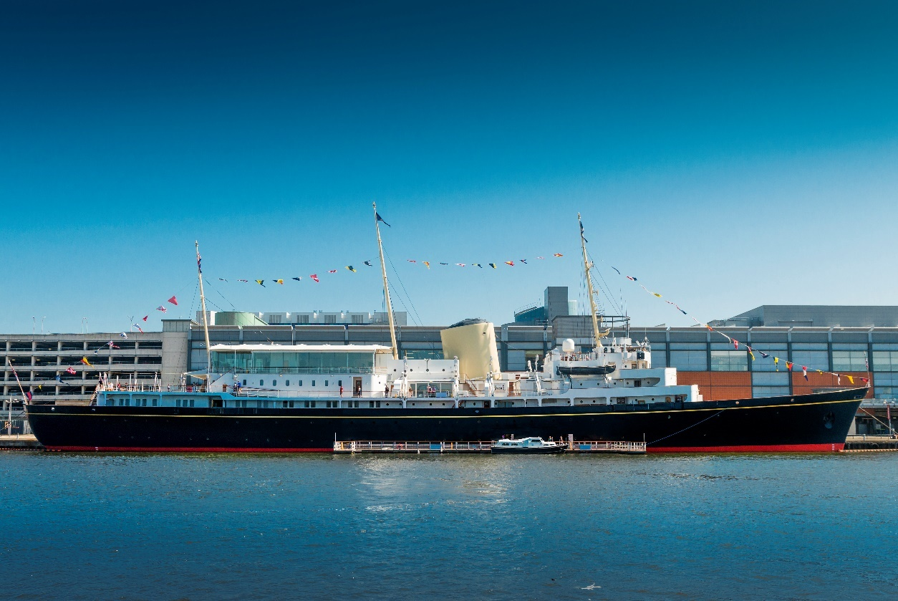
(Exterior of The Royal Yacht Britannia)

This Access Statement does not contain personal opinions as to our suitability for those with access needs but aims to describe accurately the facilities and services that we offer all our visitors.
The Royal Yacht Britannia, Ocean Terminal, Leith, Edinburgh EH6 6JJ
Please use our postcode for SAT NAV.
For full information on directions, please see our website (www.royalyachtbritannia.co.uk).

The Royal Yacht Britannia is a five-star tourist attraction and exclusive use evening events venue, berthed in Leith, Edinburgh.

Britannia was again named as Tripadvisor’s No.1 UK Attraction in 2023, and has retained its Tripadvisor Travellers’ Choice Best of the Best Award, which is awarded to less than 1% of Tripadvisor’s listings.

The Royal Yacht Britannia is highly accessible for wheelchair users or those with specific access needs. Entry is via Ocean Terminal Shopping Centre, which has a multi-storey car park, including dedicated accessible parking spaces on Levels C and E, and lifts. It is not possible to directly access the Ground Floor of Ocean Terminal using the car park's lifts. Please see the ‘By Car’ section for detailed information about access through the car park.

If you require any further information about specific access or need advice on planning your visit, please contact us:
+44 (0) 131 555 8800 (Monday to Friday 9am – 5pm) or email enquiries@tryb.co.uk.
If we have not covered your access requirements in this document, please contact us and we will be happy to discuss your needs and offer assistance where we can.

Contents

Access Statement for The Royal Yacht Britannia 1
General information 7
About us 7
Pre-arrival 9
By rail 9
By tram 9
By taxi 15
By bus 15
By bike 17
By car 17
Arriving by bus, tram, taxi, bicycle or on foot 23
Access from Ocean Terminal Main Entrance 27
Wheelchair users 28
Buggies 28
Main Britannia entrance and ticketing area 29
Arriving at our entrance 30
The tour 36
Signage 39
Britannia tour (displays, exhibits) 39
Public access on board 40
Lift tower 40
Onboard lift to the Royal Deck Tearoom 41
Doorways, floor coverings, lighting, stairs, ramps 43
Public toilets 45
Royal Deck Tearoom 48
Dietary requirements 49
Gift Shop 50
Additional Information 51
Wheelchairs 51
Assistance dogs 51
Staff training 52
First aid 52
Smoking area 53
Local accommodation providers 53
Feedback 54
Contact information 55

General information

About us
- We aim to provide the best possible customer experience for everyone.
- Britannia was again named as Tripadvisor’s No.1 UK Attraction in 2023, and has retained its Tripadvisor Travellers’ Choice Best of the Best Award, which is awarded to less than 1% of Tripadvisor’s listings.
- Britannia is berthed in Leith, Edinburgh, just 2 miles from the city centre.
- Access to Britannia is through Ocean Terminal Shopping Centre (Ground Floor of the shopping centre itself).
- We have British and American Sign language tablets, an audio tour in over 30 languages, Braille script, plus basic English, a version for the visually impaired and a children’s version in English of our tour.
- At the Handset Desk we have straps which allow the audio guides to be worn around the neck. Headphones are also available.
- The audio tour is available to listen to on your mobile phone during the tour. We encourage our visitors to bring their own headphones but there are disposable headphones available.
- For opening dates and times, please see our website.
- On average tours last 1.5 – 2 hours, but please allow longer if visiting our Royal Deck Tearoom.
- We have accessible toilets prior to boarding.

Pre-arrival
We are just 25 minutes' drive from Edinburgh city centre. Our entrance is in Ocean Terminal on the Ground Floor. You can get to The Royal Yacht Britannia by train, tram, bus, bike, car and taxi.

By rail
The nearest train station is Edinburgh Waverley, this is 2.3 miles from Ocean Terminal. There is a taxi rank outside the station. It will take around 20-25 minutes by taxi to Britannia from Edinburgh Waverley. This may vary depending on the traffic.

By tram
- There is a tram stop situated on Ocean Drive, outside Ocean Terminal Shopping Centre. Trams frequently run to and from the city centre.

- Edinburgh Trams also now run from Edinburgh Airport through Edinburgh city centre and down to Leith.
- To visit Britannia, get off the tram at the stop ‘Ocean Terminal’. The tram stop at Ocean Terminal is located on Ocean Drive, outside Ocean Terminal Shopping Centre, in the centre of the road.
- All trams feature low entrances.

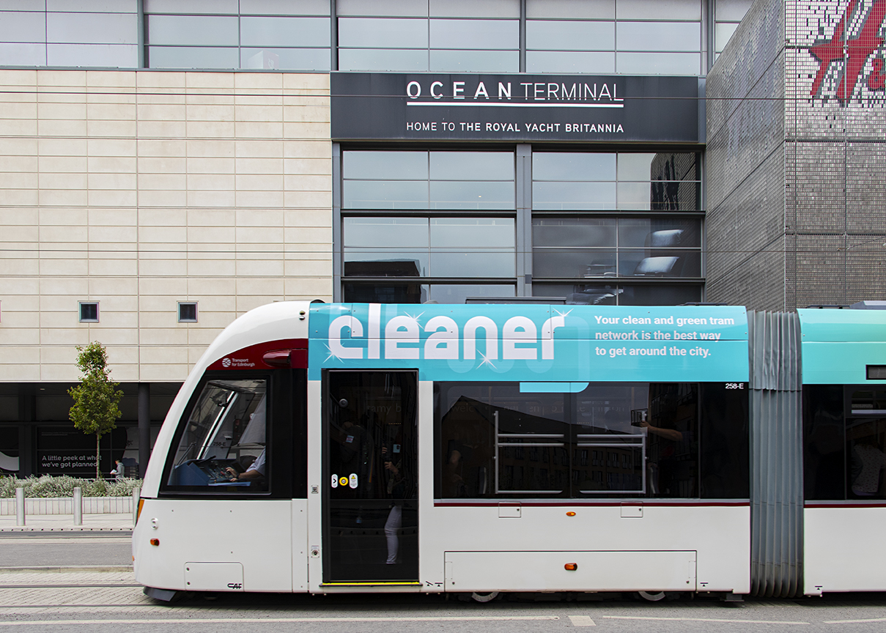
(Exterior of a tram with Ocean Terminal Shopping Centre in the background)

- There is corduroy tactile paving at the tram stops and there is both corduroy tactile paving and a sloping pavement down towards the pedestrian crossing to cross over the road to Ocean Terminal Shopping Centre.

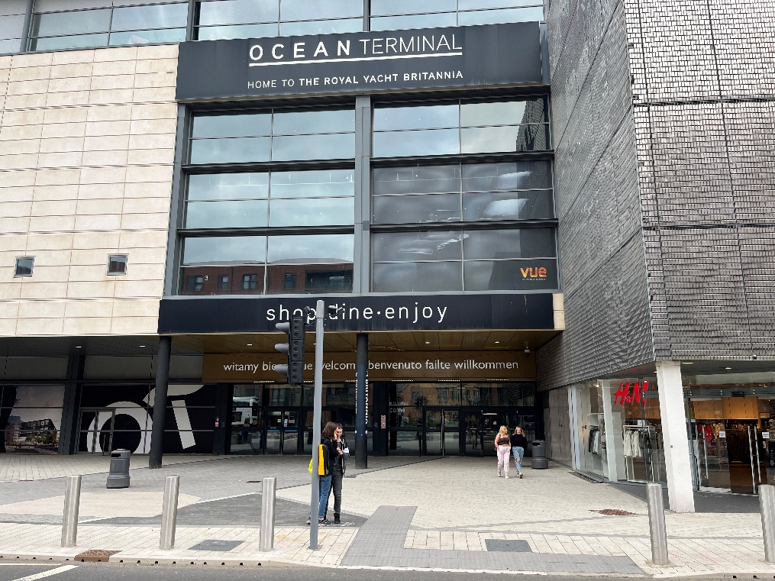
(Exterior of Ocean Terminal Shopping Centre showing the pedestrian entrance)

- There are dedicated spaces for wheelchairs and mobility scooters on every tram, located in the middle carriage of the tram. A wheelchair symbol on the tram stop platform indicates where to wait.
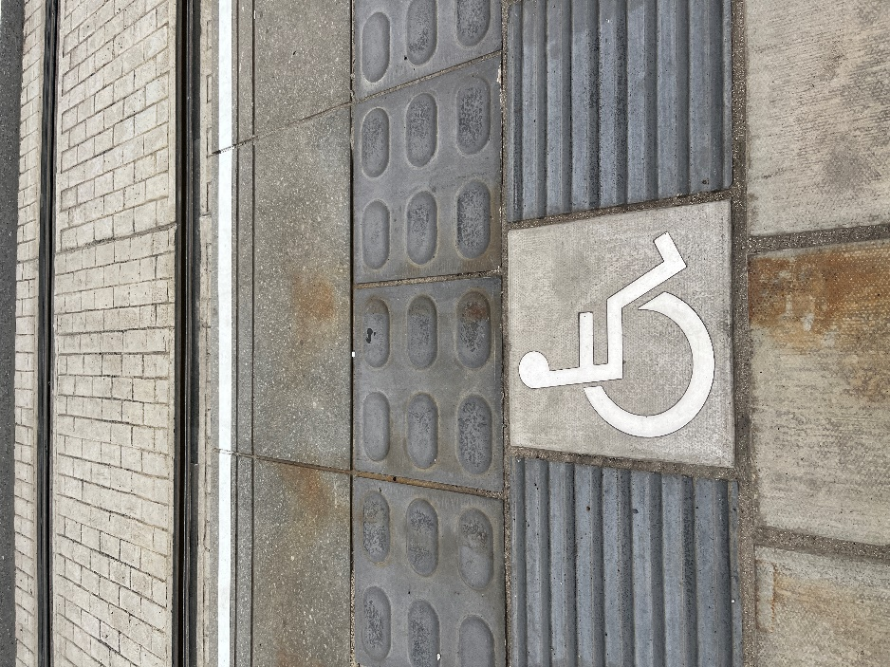
(Tactile paving)

- Due to space limitations, the trams can only accommodate up to Class II mobility scooters.
- A single journey on Edinburgh Trams costs £2.00 each way in the city zone. Child tickets are £1.00 each way. If you are returning to the city, you can purchase a return ticket for the same day at £3.80 for adults and £1.90 for children. Tickets must be purchased from the machines on the platform before travel. Ticket vending machines accept most debit and credit cards including American Express as well as 5p, 10p, 20p, 50p, £1 and £2 coins. No change is given. If you are travelling to or from Edinburgh Airport there is a single ticket for £7.50 or an open return for £9.50.

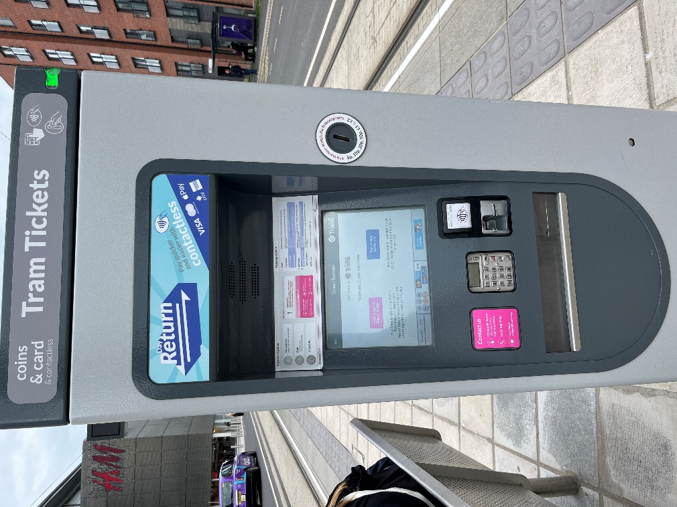
(Tram ticket machine)

- If you have an Edinburgh Trams Ridacard or citysmart card this must be validated at the grey machine on the tram platform, before boarding. A journey has been deducted when the green tick comes up on screen. You must board within 30 minutes of validation.

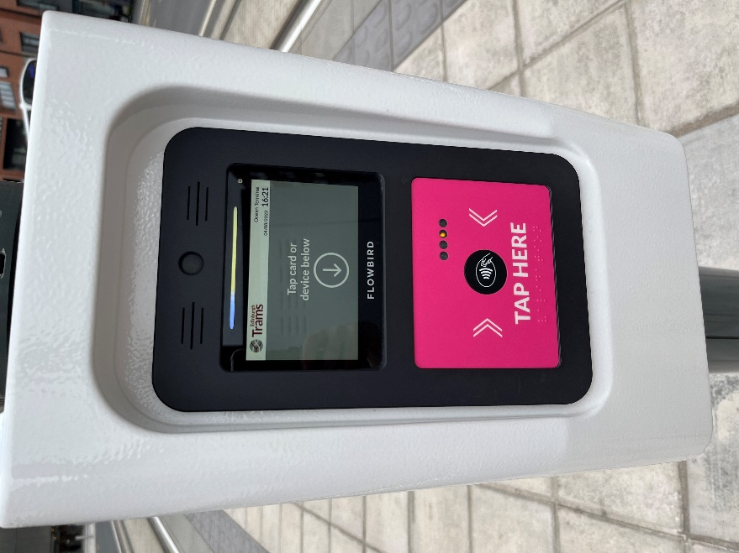
(Machine to validate tram tickets)

Edinburgh Trams have:
- Low entrances throughout the vehicle.
- High visibility handrails.
- Two dedicated wheelchair/buggy spaces per tram.
- Dedicated disabled priority seats.
- Passenger alert buttons signposted in Braille for blind and partially sighted tram users.
- You can read more information on the Edinburgh Trams Accessibility page.

By taxi
There currently is no designated taxi drop-off point. Taxi drivers will drop you off as close to Ocean Terminal as possible.

Our preferred taxi supplier is Central Taxis. All Central Taxis are wheelchair accessible. They offer a mix of 5-seater TX Hackney cabs, 6-seater Mercedes M8 taxis and Peugeot E7 taxis, each of which is supplied with a wheelchair ramp, seatbelts and additional safety anchors. All drivers have completed training in Wheelchair Access and Disability Awareness.

By bus
- Buses frequently run to and from the city centre.
- Lothian Bus services from Edinburgh city centre are numbers 10, 16, 34 or 35.
- The bus stops are located outside Ocean Terminal Shopping Centre on Ocean Drive, except the number 16 Lothian Bus, which is on Commercial Street. Commercial Street is at the crossroads with Ocean Drive and North Junction Street. The number 16 bus stop for Britannia is outside Leith Job Centre and the number 16 bus stop travelling towards the city centre is on the opposite side of the road to the Leith Job Centre.
- Regal Tour buses depart from Waterloo Place, just off Princes Street in Edinburgh’s city centre. The Regal Bus stops outside Ocean Terminal Shopping Centre.
- A single journey on a Lothian Bus is currently £2.00 and a child single journey costs £1.00. Please note you must have the correct amount (no change is given) or use a contactless card. A day ticket is available for £5.00 or capped at £4.80 when the same contactless card is tapped for three or more journeys.

All Lothian buses are easy access
They have:
- Low entrances that can “kneel” to kerb height to give step free access where possible.
- Retractable boarding ramp for wheelchair access.
- High visibility handrails.
- A dedicated wheelchair space.
- Drivers are specially trained to help customers enjoy the full benefit of their buses.

By bike
- There are bike racks situated at the front of Ocean Terminal.

By car
- For satnav, our postcode is EH6 6JJ. Follow signs for Edinburgh and Leith, or North Edinburgh. Then follow brown Britannia signs. FREE parking is at Ocean Terminal in a multi-storey car park. (Level C of the car park is nearest to our entrance and has accessible parking spaces).
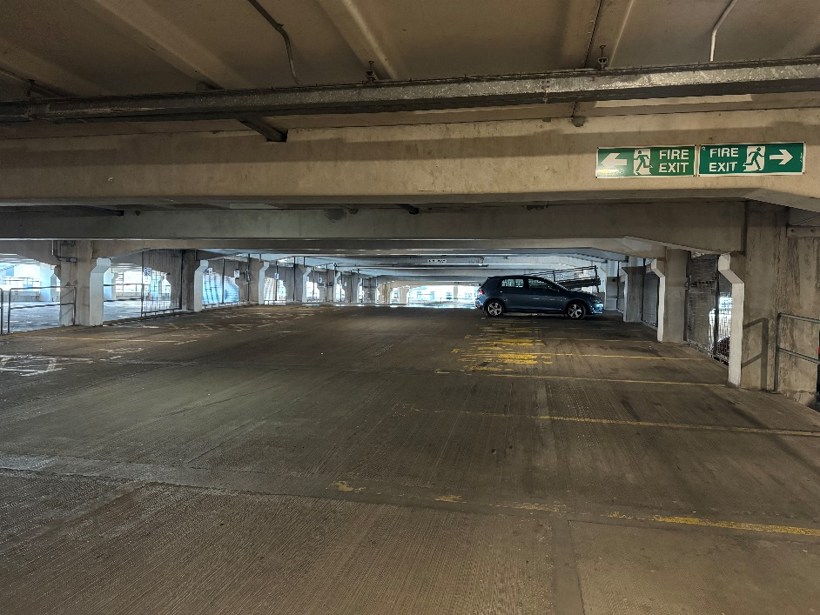
(Ocean Terminal multi-storey parking)

- The nearest dedicated parking for wheelchair users and people with access requirements is in the car park of Ocean Terminal on Level C.
- The surface of the multi-storey car park is concrete. The car park is well lit.

Ocean Terminal Free car parking:

Car park level | No. of blue badge car parking spaces
Level C | 22
Level E | 11

- It is not possible to directly access the Ground Floor of Ocean Terminal by the car park lifts. For this reason, we suggest parking on Level C or E, which have access into the Shopping Centre.
- On entry to the shopping centre from the multi- storey car park (Level C) there are 2 automatic outward opening doors on the left-hand side. The width of these is approximately 1560mm.
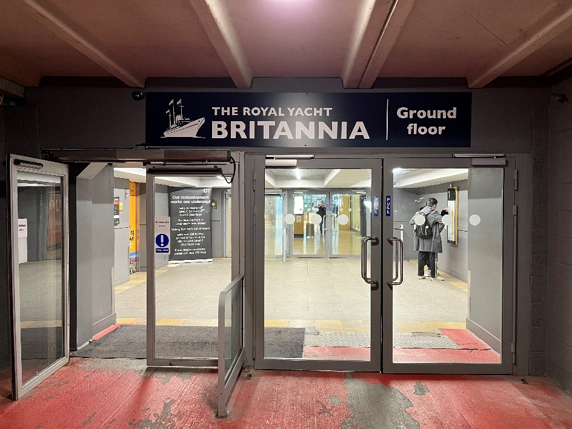
(Entering from level C of the car park into the 1st floor of the shopping centre, with a set of outward facing automatic on the left and manual set of doors on the right, as shown in the above picture)

- After entering through the first set of automatic doors, each level has two lifts but they do not serve the Ground Floor of the shopping centre, where Britannia’s entrance is located. If parked on car park levels A, B, D, F and G, take one of these car park lifts to level C. If you parked on level C or E, you can enter the shopping centre through the next set of automatic doors.

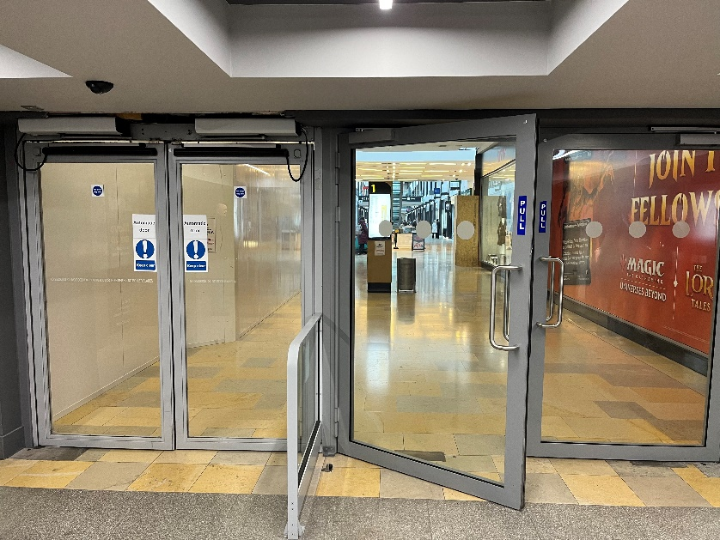
(1st floor inner entrance to Ocean Terminal, the second set of automatic doors with an outward automatically opening set of doors on the left and a manually opened set of doors on the right)

- Once inside the shopping centre, use the lift at the far end to go down to the Ground Floor.
- The lift inside Ocean Terminal Shopping Centre has a button for emergencies and can take up to 1600kg of weight, maximum 21 people.

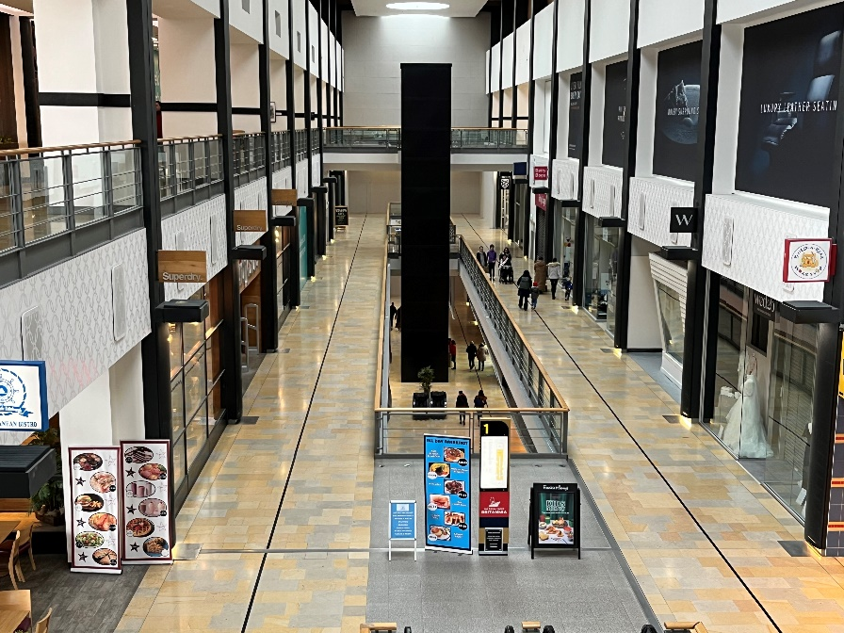
lift tower
(The lift tower inside Ocean Terminal from the second floor)
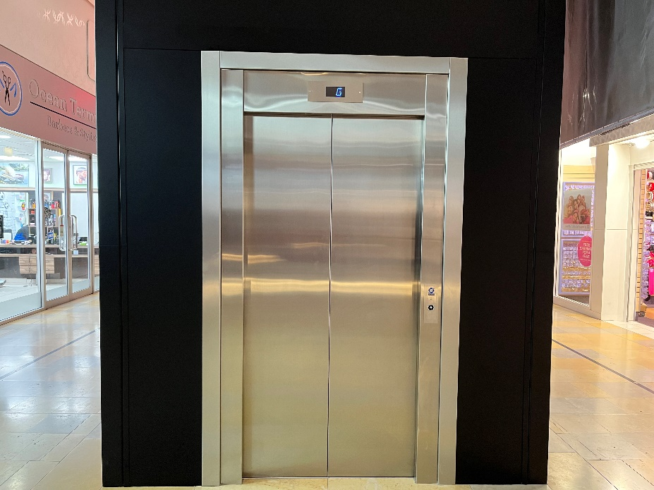
(Lift access to Britannia within Ocean Terminal Shopping Centre. This lift has a width of 1002mm)

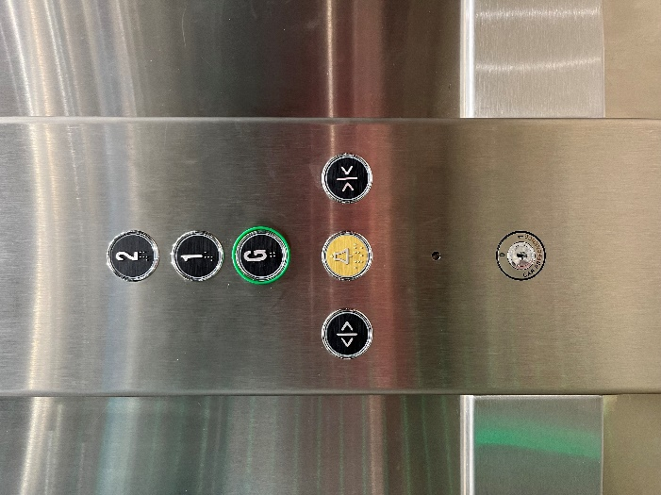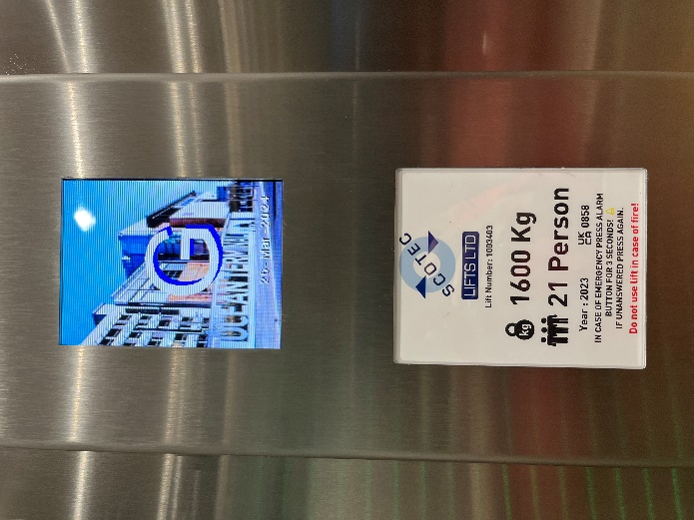
(Left image shows the lift buttons inside the Ocean Terminal lift. The right image shows the floor level display within the lift)

- When you exit the lift, the entrance is ahead on the left-hand side.

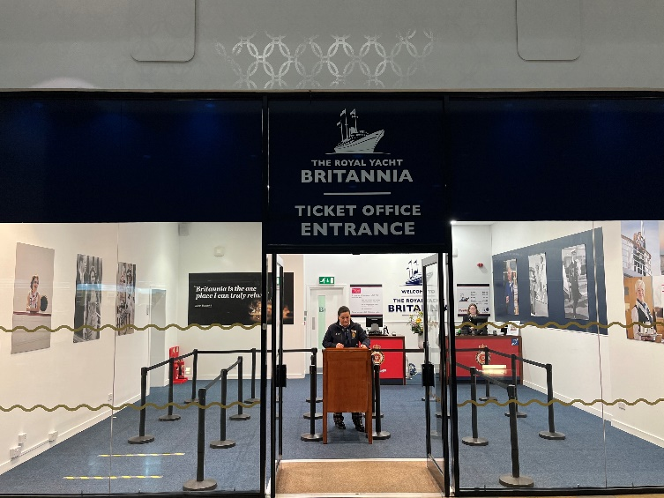
(The entrance. A Welcome Host is at a podium to greet visitors. The podium may be just outside of the entrance)

- There is a welcome desk on arrival to our entrance, which is always staffed. We have hearing induction loops throughout Britannia. There is also complimentary Wi-Fi throughout.

Arriving by bus, tram, taxi, bicycle or on foot
If arriving by bus, tram, taxi or if you are on foot, access to Britannia is from the Ocean Terminal Shopping Centre main entrance on the ground level.

Please note that you will not see Britannia, as the Yacht is permanently berthed behind the shopping centre.

Outside Ocean Terminal (left-hand set of doors)

The main entrance to Ocean Terminal is at street level. There are 4 double sets of doors. The first pair of doors on the left open outwards automatically.
The second pair of doors are manual. Each has a width of 1570mm.

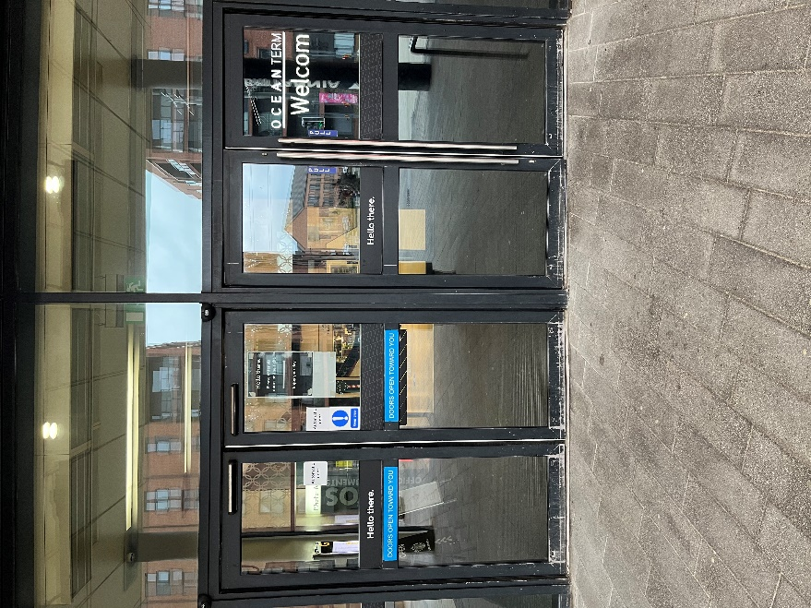
(First set of outer doors to Ocean Terminal. As shown above, the doors on the left open automatically. A set of manually opened doors are shown to the right)

Within Ocean Terminal (left-hand set of doors)

Once inside Ocean Terminal, there is a second set of doors. The pair of doors on the left is opened by a push button. The set of doors on the right are opened manually.

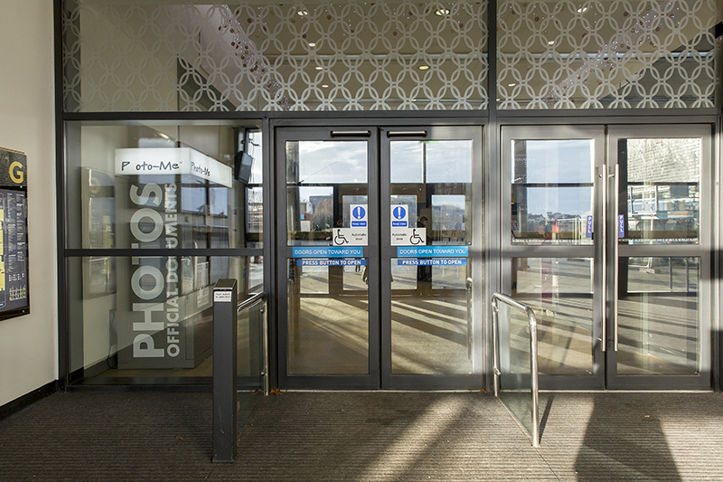
(The inner set of doors inside Ocean Terminal)

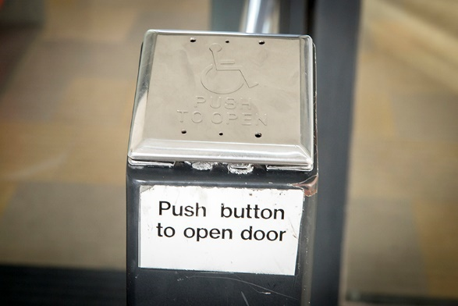
Push button access

(The doors on the left are opened by a push button)

Outside Ocean Terminal (right-hand set of doors)

The third pair of doors are manual and the fourth pair of doors are automatic inline sliding doors.

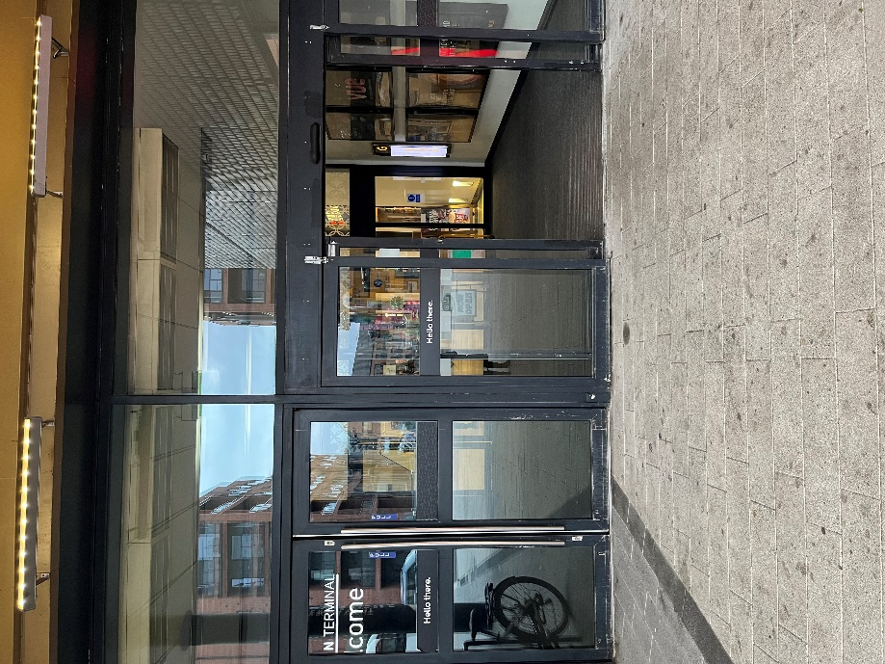
(Entrance doors to Ocean Terminal)

Inside Ocean Terminal (right-hand set of doors)
Once inside Ocean Terminal through these doors, there are a pair of manual doors on the left side and a pair of inline sliding doors on the right.

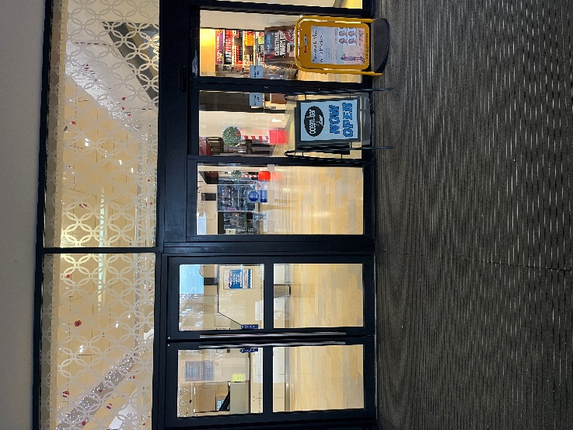
(Within Ocean Terminal there is another set of doors A pair of manual doors on the left and a set of automatic doors slide open on the right-hand side)

Access from Ocean Terminal Main Entrance
From the main entrance to Ocean Terminal, go ahead towards Boots and turn right. Proceed along the concourse, past H&M and Claire’s Accessories to find the entrance on the left-hand side to start the tour.

Wheelchair users
- Please note: Shopmobility scooters and electric wheelchairs are generally unsuitable on Britannia due to the gradient of the ramps on board.
- Britannia is classed as Category 1, the highest level for wheelchair access without assistance, by VisitScotland. To access the whole tour, wheelchairs should be no wider than 670mm, in order to negotiate some narrow passageways and corners.
- If your wheelchair exceeds 670mm in width, we have two wheelchairs available for your use at the temporary entrance, at no extra charge. Please ask to use a wheelchair at the ticket desk.

Buggies
- Buggies are welcomed on board Britannia. All but the widest double buggies will have full access to the Britannia tour (max width 670mm). We have baby changing facilities at the four sets of toilets on board. We have highchairs in the Tearoom.

Lift Tower
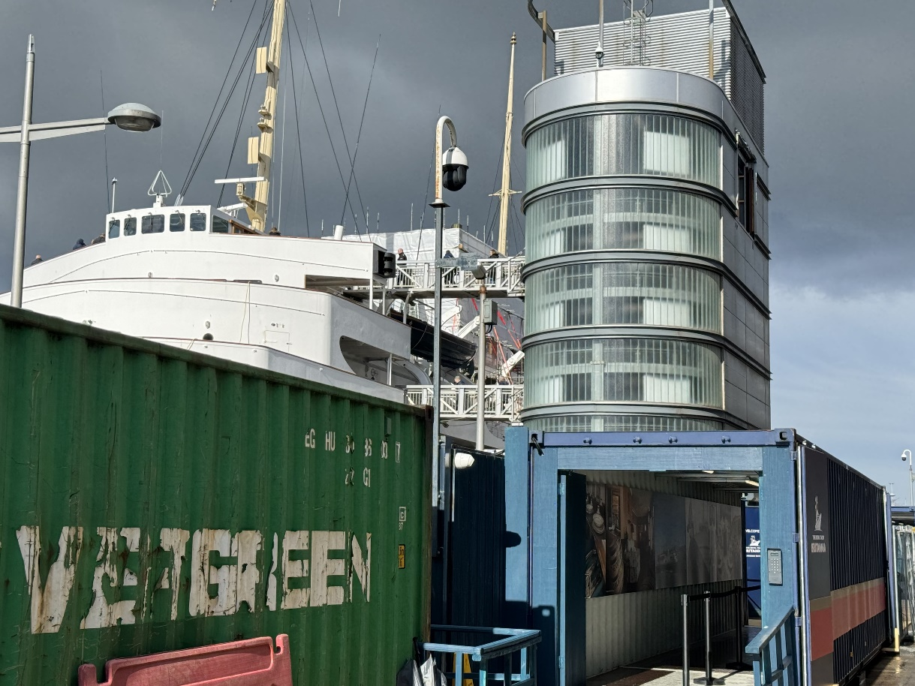

(The Royal Yacht Britannia, with lift access to five decks via the Lift Tower, pictured above)

Each of Britannia's decks are accessed via a shore-side Lift Tower and stairwell. Any seats without ropes or signage are there for you to sit on and enjoy your audio tour.

Main Britannia entrance and ticketing area
Due to the upcoming construction work at Ocean Terminal Shopping Centre, Britannia will be closed 25 - 28 June. As part of this redevelopment, Britannia will also be gaining a new Visitor Centre and Gift Shop which will involve us operating out of temporary accommodation whilst these new facilities are being created.

Arriving at our entrance
On arrival at the Ground Floor of Ocean Terminal, you will find our temporary entrance at the East end of the building.
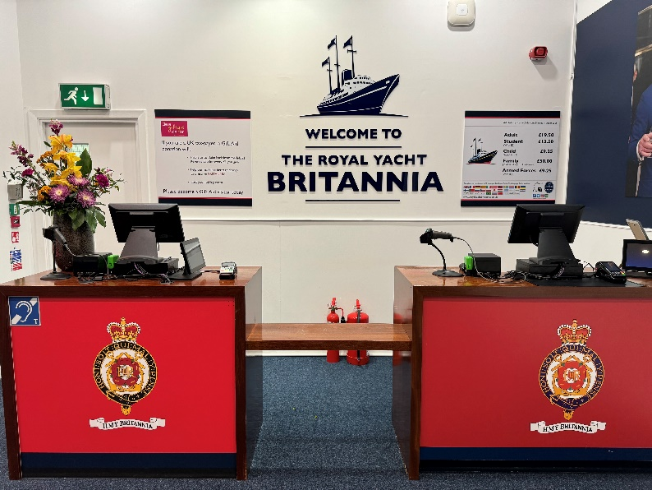
(Above: Inside the entrance there are two ticket desks. At least one will be staffed)

There is a lower counter, pictured below, suitable for wheelchair users. The payment/information desk area has a hearing loop.
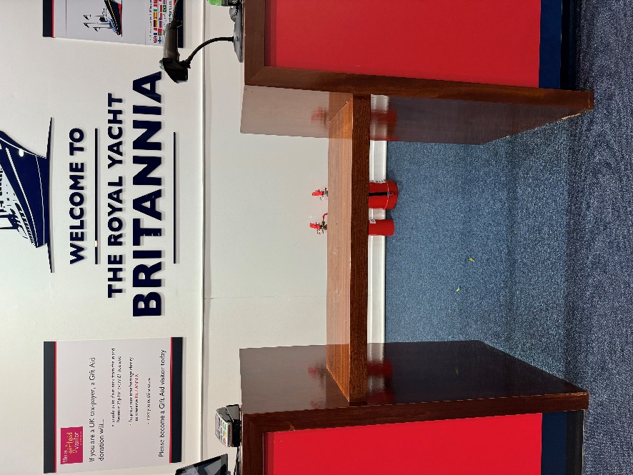
There are no steps at the entrance. There is seating available before proceeding on board Britannia. The floor is made of carpet.
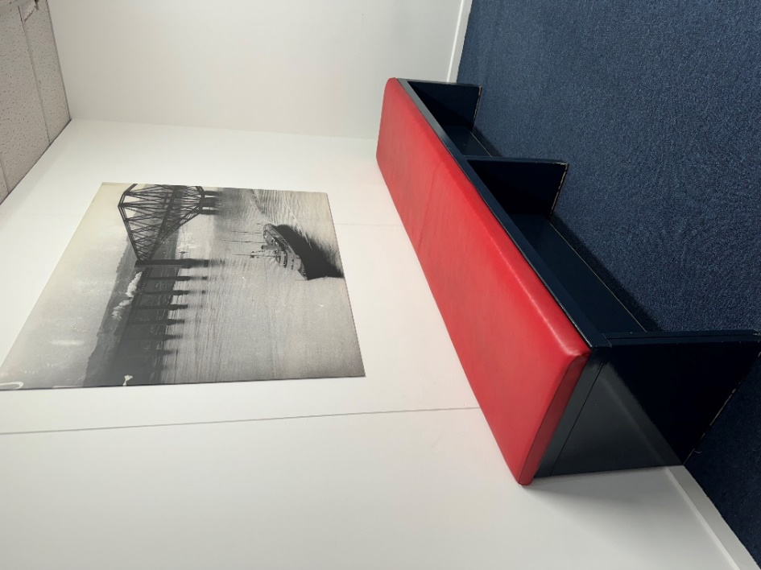
(Seating area before boarding Britannia)
We can offer a pen and pad of paper to assist people in the entrance and also have a magnifying glass available.

Tickets can be purchased for the Britannia tour from the ticket desk, or in advance online via our website – www.royalyachtbritannia.co.uk. Should a complimentary carer ticket be required, this can be requested at the ticket desk on the day.

To reach Britannia from the entrance, visitors will go through a service corridor, then outside the building across a service road, where there is a dropped kerb. A Visitor Assistant will be outside to guide visitors to a shipping container which leads them to access the ship and tour. To assist with accessibility, there is a ramp going up into the container and another ramp going down after exiting the container.
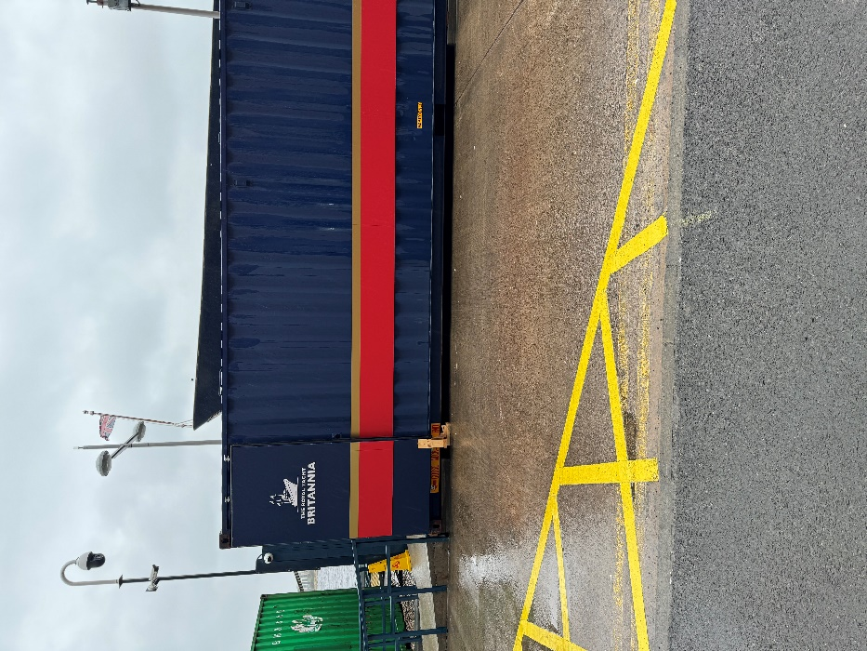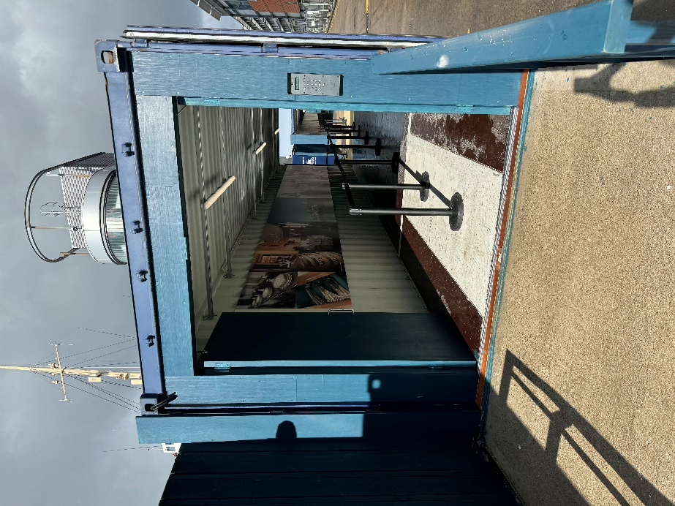
(Above left: The pavement outside the service corridor, road and the exterior of the container.
Above right: A ramp leading up to the container where visitors will enter and exit through after completing the tour)

After the container, visitors will go through a blue gate.

The floor surface between the shipping container and the blue gate is mini-mesh grid grating.

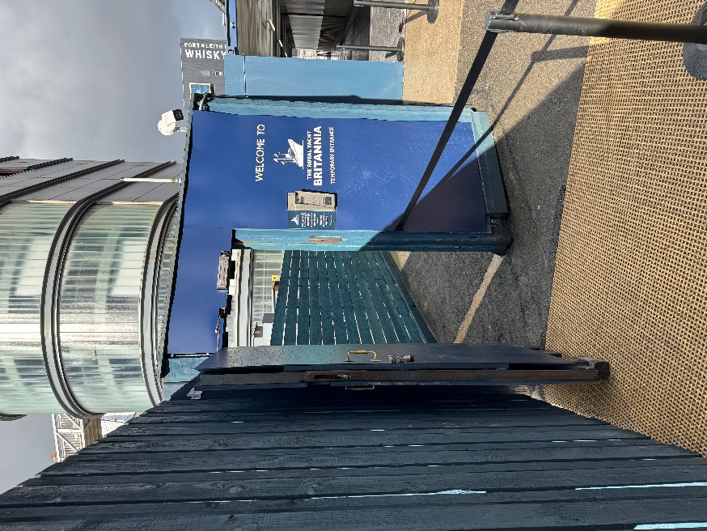
(The gate into the Britannia compound with mini-mesh grid grating)

After the gate and on the right-hand side, there are five metal steps up with handrails on both sides and on the left-hand side, an open vertical platform lift with an outward opening door. There is a ramp up into the lift. Total capacity for the lift is 2000kg. Assistance will be provided if lift access is required.

Visitors will then reach the lift tower and stairs which accesses all levels of Britannia.

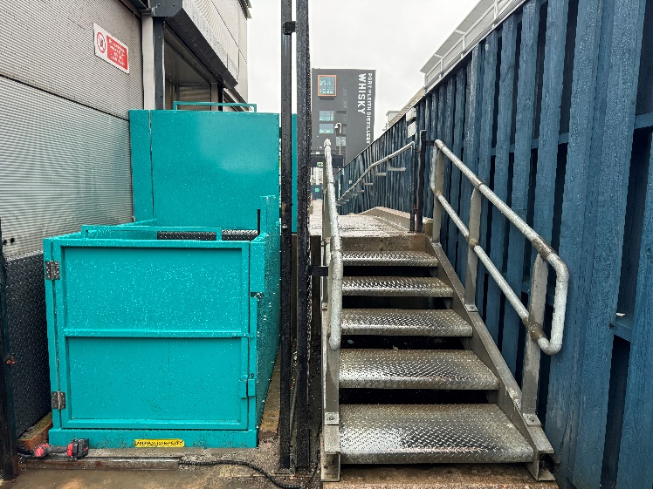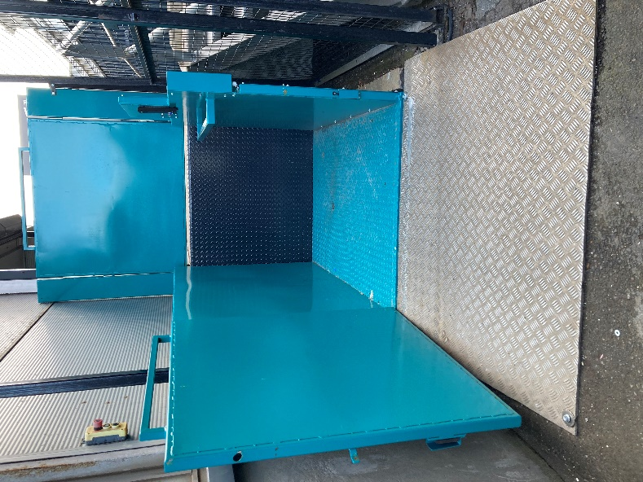
(Above left: the vertical platform lift and stairs. Above right: the ramp up into the lift)

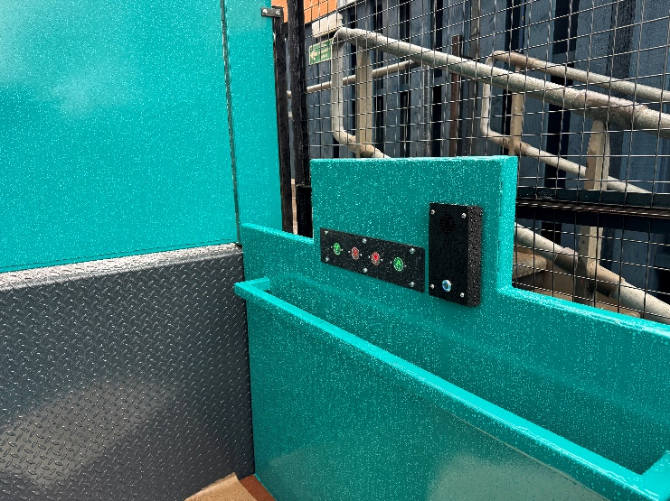
(A close-up of the vertical platform lift control buttons)

An alternative lift-free route is available through shipping containers. Please ask for assistance from a Visitor Assistant. Visitor Assistants wear either red jackets or a navy blue and tartan uniform.

Once visitors have completed the tour, the exit through the Britannia compound is via a gate in the fence and through two shipping containers, before entering back through the building into Ocean Terminal Shopping Centre.
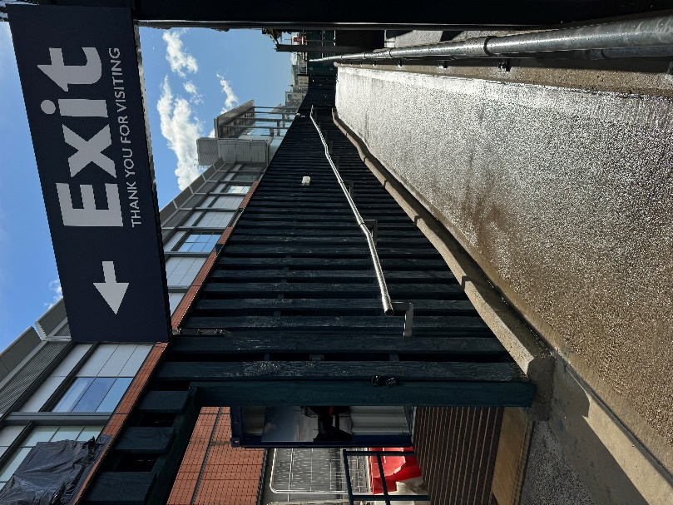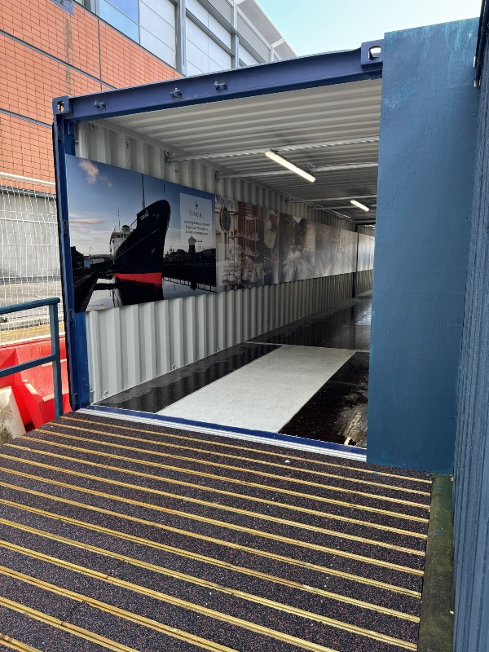
(Above left: The exit gate. Above right: A ramp leading up into the container after the exit gate)

The tour
Our audio tour is available in over 30 languages, a Basic English version, a version for the visually impaired and a children’s version in English. Visitors with learning difficulties or those whose first language is not English may find the Basic English audio tour suitable.

The tour is available in British or American Sign Language on a tablet. We also offer the tour in Braille script. We have a printed version of our English language tour in large font – please request this at the Handset Desk before you make your way on board Britannia. We have Visitor Assistants situated throughout our tour, who are on hand to answer questions and help where possible.

Our audio handsets have adjustable volume control, so you may wish to also take the handset tour.

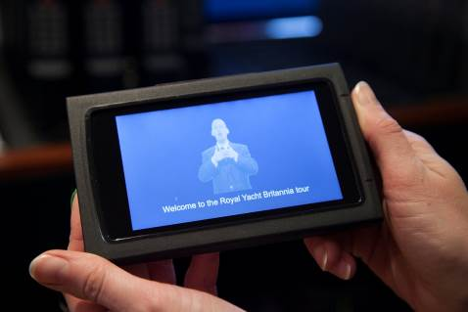
(Britannia’s British Sign Language Tablet)

We have Visitor Assistants situated throughout our tour, who are on hand to assist our visitors. The Visitor Assistants are smartly dressed in Britannia’s tartan and in colder weather have a red jacket.
Sensory packs are available from the Handset desk, similar to as pictured.
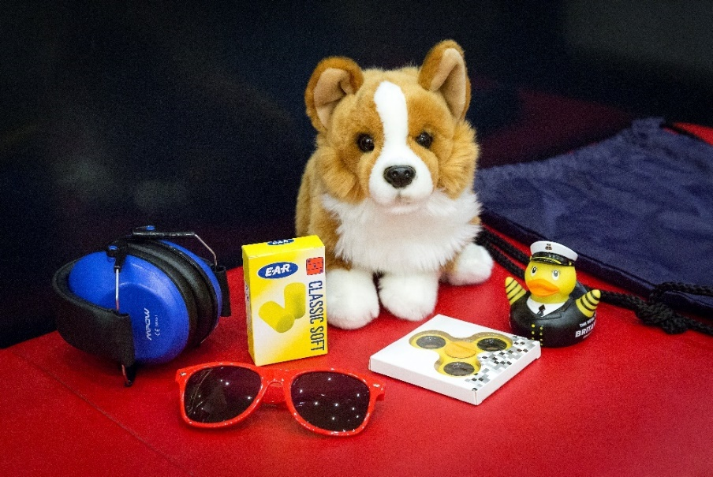

(Sensory pack)

Signage
General signage on board Britannia is white with navy blue text. The disc signs throughout the tour advise visitors which numbers to press on their audio handset tour and signify the colour of deck they are located on. Each deck has a colour, namely red, blue, gold, purple and grey.
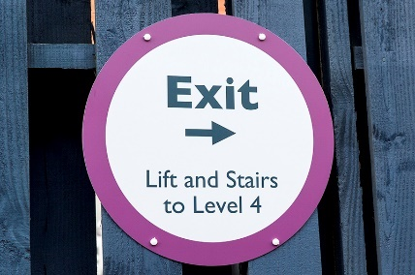
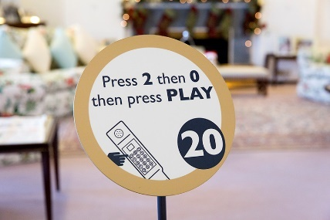
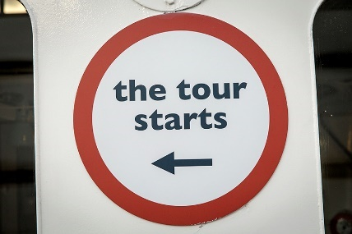

(Signs on the tour route)

Britannia tour (displays, exhibits)
- Many exhibits on board have a descriptive sign next to them in English.
- There are no displays that use flashing lights.
- There are Visitor Assistants located along the route who will be delighted to help with any queries or requests.
- There is background noise/music on the Bridge, in the Wardroom Anteroom, State Drawing Room, State Dining Room, Royal Marines’ Barracks, Chief Petty Officers’ Mess, Petty Officers’ Mess, Laundry, Royal Sailing Exhibition, entrance, Tearoom and Shop. Music is also played in the toilets on the Grey Level, and on the Blue Level on the Port side.
- Videos play in the Petty Officers’ and Royal Marine Sergeants’ Mess.
- To enhance the experience, scents are used in the Sick Bay (TCP) and Laundry (soap powder). Air fresheners are in use in all four toilets on board and in the entrance toilets. Additionally, as fresh food and fudge are prepared on board you may smell cooking on the Blue Level Port Side, Galley Corridor and near the NAAFI.

Public access on board

Lift tower
A lift tower on the quayside gives access to Britannia’s five decks, with lifts to every level and ramps onto the ship.

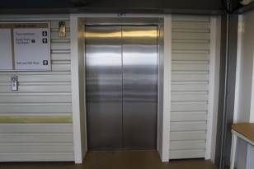

(One of two lifts in the Lift Tower)

The lift tower takes visitors to all decks and opens at all levels. It is 1100mm in width.

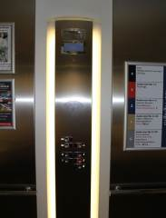
(Inside one of the lifts in the Lift Tower)

Onboard lift to the Royal Deck Tearoom
The original lift on board Britannia has a manual opening/shutting door and an automatically closing inner door. (Please note that the manual doors are heavier to open/close). The door width is 750mm. This lift offers access to the Royal Deck Tearoom and the State Apartments.

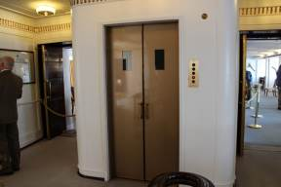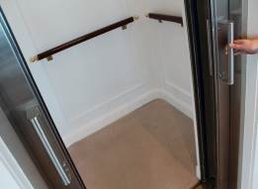
(Both images above show the onboard lift. On the left shows the lift at the State Apartments level. The image on the right shows the inside of the lift)
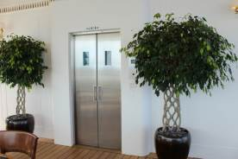
(The lift doors as seen from within the Royal Deck Tearoom)

Inside the lift, there is a panel with buttons, please press the buttons on the left side. The maximum lift load is 1200lbs or 544kg.

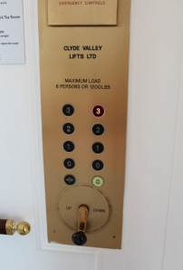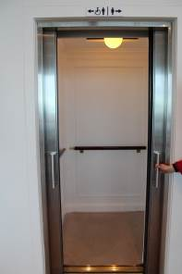
(The picture above on the left shows the buttons inside the lift. The image on the right shows the doors open at the Royal Deck Tearoom level)

Doorways, floor coverings, lighting, stairs, ramps
Floor surfaces vary from wooden decks, short pile carpet, linoleum tiles to ceramic tiles. Lighting throughout Britannia is very good, with natural light and fluorescent and LED tube lighting.
There are a few access points to note:
- The doorway on exit from the Officers’ Wardroom is 780mm width and has a light wooden door.
- There are 2 ramps allowing access to the Verandah Deck, with handrails either side.
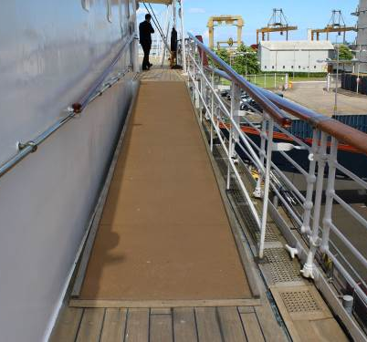
(Ramps aboard Britannia leading away from the Verandah Deck)

- If the lift is not required to access The Royal Deck Tearoom, there are external stairs up from the Verandah Deck. There are 15 stairs, with handrails either side. These stairs are original, and narrower in depth than the other staircases on board.

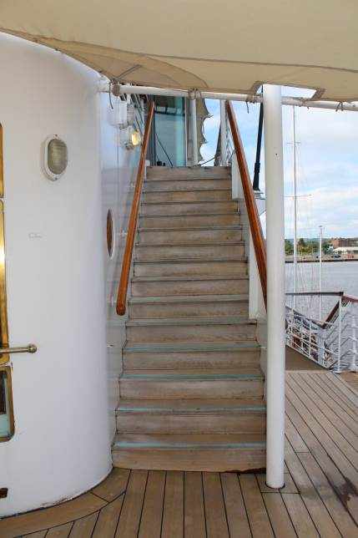
(Stairs to The Royal Deck Tearoom)

Public toilets
There are toilets situated on four levels aboard Britannia and in our entrance in Ocean Terminal.
The toilet in the entrance is located after the handset desk and prior to boarding.

Entrance
Door width: 876mm
Distance from seat: 1378mm
Seat height: 598mm

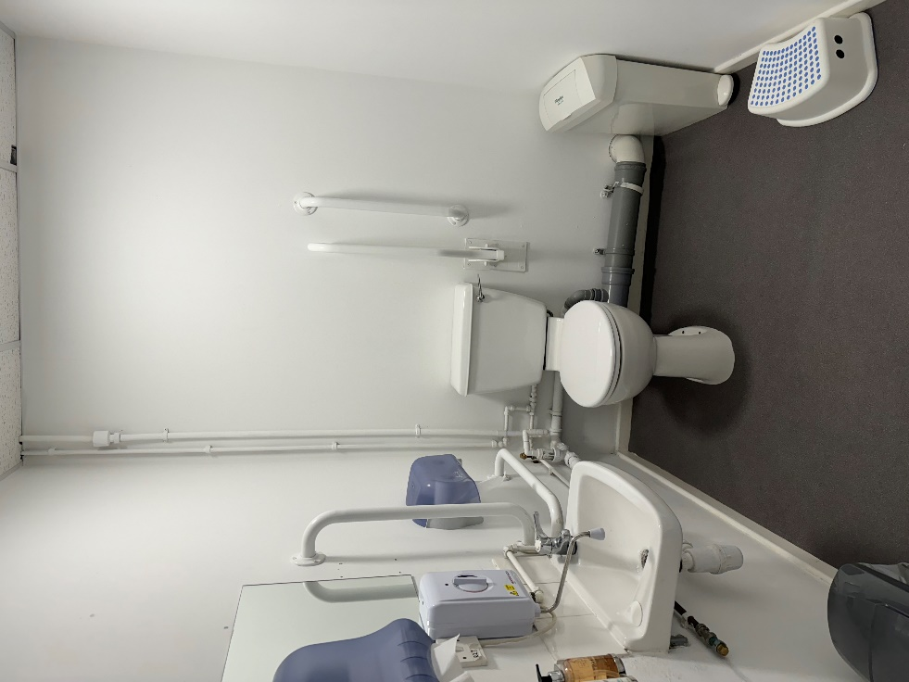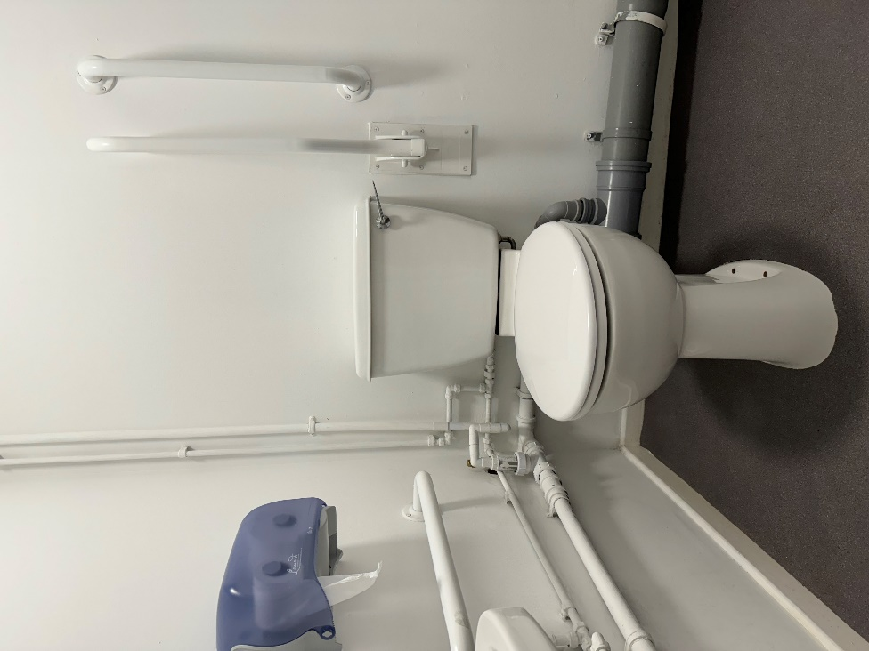
(Above left: The toilet in the entrance containing support handles and a stool. Above right: A close-up of the toilet and support handles)

Tearoom
Door width: 1000mm
Distance from seat: 1200mm
Seat height: 465mm

Sailing Exhibition
Door width: 860mm
Distance from seat: 1000mm
Seat height: 490mm

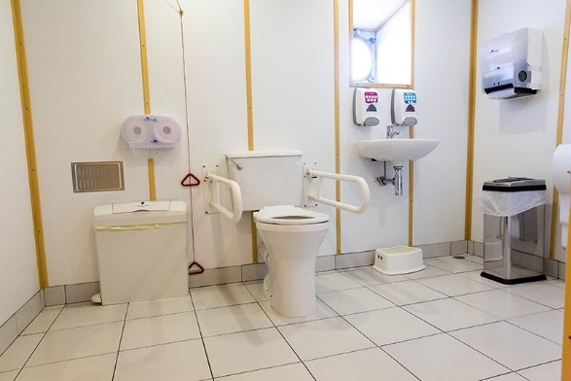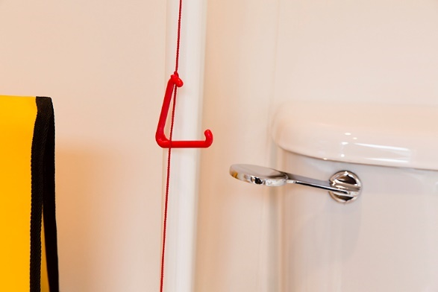

Gold level
Door width: 800mm
Distance from seat: 1200mm
Seat height: 560mm

Grey level
Door width: 800mm
Distance from seat: 1400mm
Seat height: 510mm
Please note, there is a slight slope in this toilet, due to the camber.

Royal Deck Tearoom
The Royal Deck Tearoom is situated on board Britannia. It is highly accessible for wheelchairs and buggies less than 670mm in width by internal lift from the Royal Bedrooms. The Tearoom is not accessible by Shopmobility scooters. The tables and chairs are moveable for wheelchair access.

- There are 15 steps up to the Tearoom from the Verandah deck. The door width is 1010mm and has a raised lip, which is highlighted with tape.
- The Tearoom has 35 tables and can seat 133 people. Table height is 720mm with chairs without arms. Guests are waited on with table service, by our staff.
- There are floor to ceiling windows throughout, as well as spotlighting.
- The flooring is original wooden deck.
- Our staff will happily read out the menu to customers. A magnifying glass and reading glasses are available, on request. Please ask a member of our staff.
- Crockery is white, with silver teapots. Our tabletops are cream coloured. There are accessible WCs within the Royal Deck Tearoom.
- There are highchairs available for younger children and baby changing facilities.

Dietary requirements
- The menu caters for vegetarians and vegans and there are gluten-free and dairy-free cakes, scones, soups and sandwiches available.
- We also have gluten-free bread available for our sandwiches and our potato wedges are gluten and dairy free.
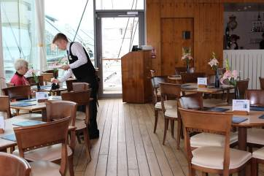

(Royal Deck Tearoom showing spacing between tables)

Gift Shop
- Britannia’s Gift Shop is located within Ocean Terminal shopping centre, opposite the temporary entrance and can be accessed directly from Ocean Terminal without having to visit Britannia itself.
- A magnifying glass is available to borrow from the till point.

There is background music in the shop and a Britannia DVD, which plays on a screen, with sound. There is a hearing loop system within the shop. Britannia staff are happy to offer any assistance where required.

Additional Information

Wheelchairs
If you are a wheelchair user and the measurements of your wheelchair exceeds 670mm we are happy to offer you a loan of one of our wheelchairs, available free of charge. Please note our wheelchairs do not have lap seat belts. Our staff are positioned throughout the tour to answer questions and provide general assistance.

Assistance dogs
Assistance dogs are welcome on board Britannia. We have dog water bowls located in the entrance, in the Gift Shop and outside by the Royal Barge, next to the statue of a Former Royal Yachtsman. Should your dog require the toilet, please ask a member of our team who will be happy to escort you to our onboard facilities.

Evacuation Chair
In the event of an evacuation on board, we have an Evac Chair – The World’s No.1 Stairway Evacuation chair, which trained members of our team will administer on the day from the Tearoom.
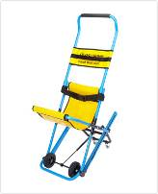
(Evacuation chair)

Staff training
There is an ongoing programme of training with our staff.

First aid
There is a first aid room on board and there are members of staff who are trained in general first aid.

Smoking area
Smoking is not permitted within the entrance or on board. There is however a designated smoking area outdoor next to The Royal Barge.

Local accommodation providers
The Holiday Inn Express is the nearest hotel to Britannia.
Holiday Inn Express, Britannia Way, Ocean Drive, Leith, Edinburgh, EH6 6JJ.

The Holiday Inn Express is 0.3 miles from Britannia. The Holiday Inn Express has 9 double accessible rooms with wheel-in access shower rooms. All rooms have flashing fire alarms, emergency lighting and emergency pull cords in both the bedroom and bathroom area. They also have a vibrating pillow that can be moved from room to room, which is linked to the fire alarm system to alert people who are deaf or have hearing loss should the fire alarm be activated. There is also an ‘Evac Chair’ so that disabled guests can evacuate the building in the event of a fire.

There are no accessible twin-bedrooms, however there are adjoining rooms for carers which are provided free-of-charge. Please note that these interconnecting rooms must be booked directly with the hotel to ensure availability.

There are no stairs at the entrance to the hotel. The reception desk has a lowered area. Both the bar and breakfast room are on the ground floor with easy access.
Contact details for The Holiday Inn Express:
http://www.expressedinburgh.co.uk/

Feedback
If you would like to provide us with any feedback on this Access Statement, we would welcome your comments. We would be interested to hear if there is any information we may have missed that would be of interest. Please email us: enquiries@tryb.co.uk or by telephone +44 (0) 131 555 8800 or simply speak to a member of our team when you visit Britannia.

Contact information
Address: The Royal Yacht Britannia, Ocean Terminal, Leith, Edinburgh, EH6 6JJ
Telephone: +44 (0) 131 555 5566 / +44 (0) 131 555 8800.
Email: enquiries@tryb.co.uk
Website: www.royalyachtbritannia.co.uk

